
ACADEMIC TALK
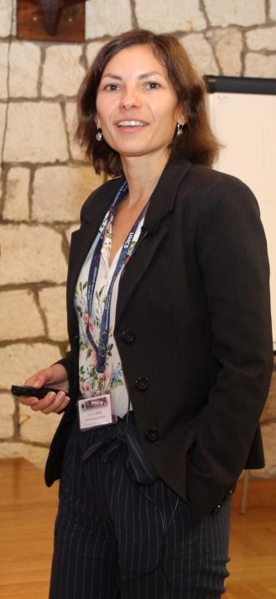
About the speaker
Kamila Sieja finished her PhD in theoretical nuclear physics with a double degree from the Marie Curie-Skłodowska University in Poland and Universite Bordeaux 1 in France. She was then a postdoc at GSI Darmstadt and IPHC Strasbourg. She holds a permanent position at CRNS since 2012 and now heads the theory group at IPCH Strasbourg. Her research is focused on nuclear structure and reactions with applications to astrophysics.

Affiliation: CNRS & University of Strasbourg

5th July 2024, friday 1.00pm-3:00PM A3-824

Talk Abstract
The Configuration Interaction Shell Model (CI-SM) is a powerful theoretical framework used to investigate the nuclear structure of atomic nuclei. In this talk, I will briefly outline the fundamental principles of nuclear structure and the various approaches employed to solve the nuclear many-body problem. I will then delve into the CI-SM framework, highlighting its capabilities in describing nuclear structure phenomena. Additionally, I will discuss the limitations of the model and explore potential strategies to overcome these challenges.

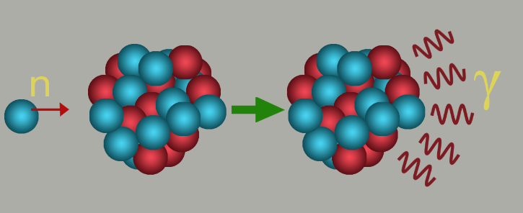
Configuration Interaction Shell Model
and Nuclear Structure Studies
Tomasz.paterek@xmu.edu.my │ Department of Physics │ Xiamen University Malaysia

